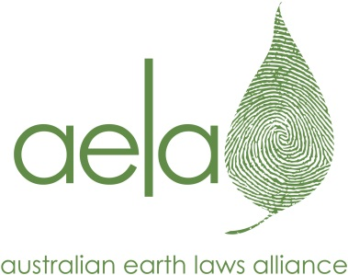 | Australian Earth Laws Alliance  30 Hardgrave Road  West End Qld 4101  www.earthlaws.org.au  convenor@earthlaws.org.au

VOLUNTEER APPLICATION

This application form is for students and professionals who would like to volunteer directly with AELA. If you are a university student seeking a university based placement or internship with AELA, please visit our website (http://www.earthlaws.org.au/volunteer-with-aela/) and fill out our Internship Application.

Once you have completed this form, please email it, together with your resume and any other relevant information, to: volunteer@earthlaws.org.au

PERSONAL DETAILS (PLEASE PRINT)

NAME: PREFERRED NAME (if different):

MALE ☐ FEMALE ☐ OTHER ☐ (Please self-identify as appropriate)

ADDRESS:

If you’ve provided a PO Box, please tell us the Town/City you’re based in:

PHONE: EMAIL:

APPLICATION INFORMATION

1. How did you hear about volunteering with AELA?

AELA event ☐ AELA website ☐ Friend/contact ☐ Other ☐ (please give details below)

2. Which areas of AELA’s work would you like to get involved with? (Please list any of AELA’s programs and project areas you’re interested in – all up to date information can be found on our website under ‘Current projects’).

3. What type of volunteer work are you interested in?

Legal Research ☐ Other Research ☐ Event Management ☐ Admin ☐

Other ☐ (please give details)

4. What days/times are you available?

5. Why do you want to work with us?

6. What particular interests, skills and/or abilities could you share with us?

7. Do you have relevant qualifications (or current study)?

8. Do you have relevant experience from previous paid or voluntary work?

9. Is there any other information that you would like to provide?

Please attach your resume and provide contact details for two referees who are able to comment on your skills, abilities and suitability for this role.

Referee 1 Referee 2

Name: Name:

Phone: Phone:

Email: Email:

I confirm that the information I have provided above is truthful and accurate.

Signed: Dated:

